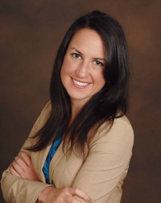

Julie is the Business Development Manager at International SOS for the Midwest Region, where her primary role is to educate companies on international Duty of Care best practices and help them with putting a program in place to support their international assignees and travelers.
Prior to joining International SOS in 2015, Julie spent five years as an expatriate, experiencing firsthand the challenges of living abroad in developed, developing and third world countries. She most recently worked in Nigeria in the oil and gas services sector, as well as managing various project in Ghana, China and France in the hospitality industry.
Julie has a MBA from ESSEC Business School in Paris, France. She also holds a Bachelor of Science in Finance and Accounting from Bentley University.

About International SOS
International SOS (internationalsos.com) is the world’s leading medical and travel security risk services company. We care for clients across the globe, from more than 1,000 locations in 90 countries. Our expertise is unique: More than 11,000 employees are led by 1,400 doctors and 200 security specialists. Teams work night and day to protect our members.
We pioneer a range of preventive programs strengthened by our in-country expertise. We deliver unrivalled emergency assistance during critical illness, accident or civil unrest. We are passionate about helping clients put ‘Duty of Care’ into practice. With us, multinational corporate clients, governments and NGOs can mitigate risks for their people working remotely or overseas.

