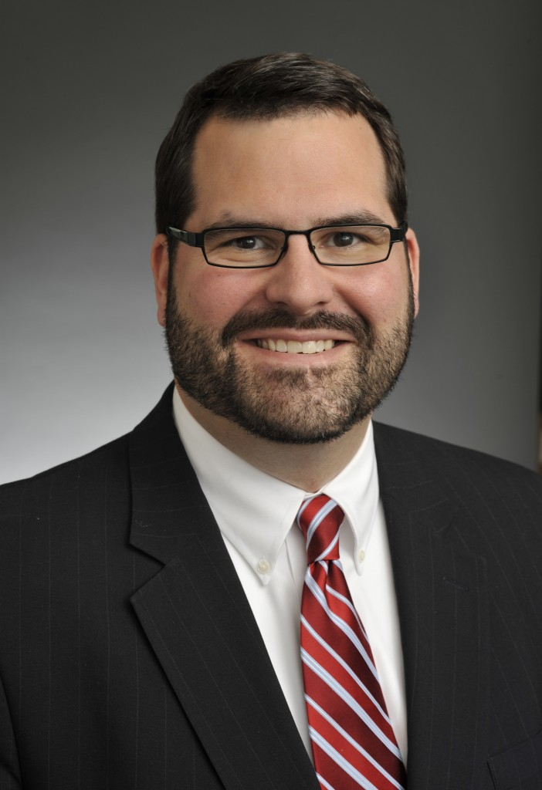

Brian J. Dusek

Partner

Brian Dusek concentrates his practice on the representation of domestic and international insurers in complex insurance coverage claims, particularly those relating to professional liability. Mr. Dusek advises insurers on coverage issues, consults with insurers on policy wording, provides risk analysis and management advice, and represents insurers in coverage litigation. Mr. Dusek is a frequent speaker on professional liability, technology, and cyber liability issues.

Much of Mr. Dusek’s practice focuses on providing monitoring counsel services to insurers worldwide in connection with claims arising under lawyers’ professional liability, insurance brokers’ professional liability, cyberliability/data protection, healthcare liability, and other coverages. Mr. Dusek works with insureds and their insurers to develop and implement resolution strategies.

Education:
University of Minnesota, B.A., 1994
DePaul University College of Law, J.D., 1998 (Article and Note Editor, DePaul Business Law Journal)

Memberships:
Professional Liability Underwriting Society (PLUS); Association of Lloyd’s Brokers; Claims Litigation Management Alliance

