

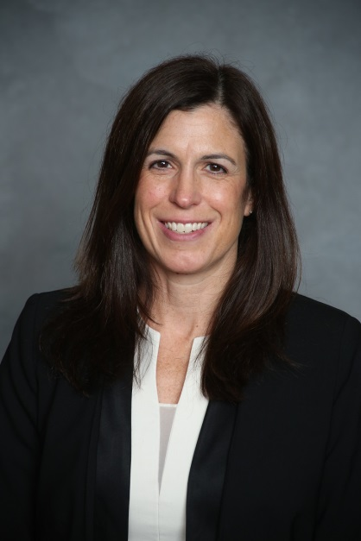

**SHELLEY NORMAN**

Shelley Norman is the AIG Financial Lines Midwest Zonal Executive. Shelley’s responsibilities include overseeing the teams responsible for Management Liability and Professional Liability underwriting in the territory. Shelley joined AIG in 1995 as an Underwriter in Financial Lines and has held several different roles within Financial Lines including Underwriting Officer for the Private Non-Profit Management Liability Division, Head of the Private Non-Profit Management Liability Division and Lead Regional Executive. She graduated from the University of Illinois with a BA in Economics.